***(****Continue with* ***Nolock_IsolationLevels.doc)***

**Alternative for Nolock is Isolation Level**

# [SET TRANSACTION ISOLATION LEVEL](http://sqlserverplanet.com/optimization/set-transaction-isolation-level)

This statement is used to set the isolation level for either a connection or a stored procedure. The most typical use I’ve seen is at the top of a stored procedure in order to avoid locking and deadlocks. This is a cleaner alternative to using WITH (NOLOCK) hints on tables. If you set the isolation level within a procedure, the isolation level will revert to its previous level once the procedure finishes.

The syntax is:

SET TRANSACTION ISOLATION LEVEL READ UNCOMMITTED;

The available options are:

* READ UNCOMMITTED – Allows dirty reads, meaning data can be read from a transaction that is not yet complete.
* READ COMMITTED – Only reads data from transactions that have already been committed.  Current transactions must wait for transactions referencing common resources to finish.
* REPEATABLE READ – Data that is being read is exclusively locked until the transaction completes.
* SNAPSHOT – The default for Oracle.  This level allows all data to be read without using locks by maintaining a snapshot of all the data being modified in “versioning” tables.  This is the only isolation level not lock based.
* SERIALIZABLE – Data that is being read is exclusive locked and inserts are prevented within this range until the transaction completes.

|  |  |  |  |
| --- | --- | --- | --- |
| * Isolation level | * Dirty read | * Nonrepeatable read | * Phantom read |
| * Read uncommitted | * ✔ | * ✔ | * ✔ |
| * Read committed | * ✗ | * ✔ | * ✔ |
| * Repeatable read | * ✗ | * ✗ | * ✔ |
| * Serializable | * ✗ | * ✗ | * ✗ |
| * Snapshot | * ✗ | * ✗ | * ✗ |

**How to change the Isolation level to “**Read committed Snapshot”**:**

Note*: When you set the READ_COMMITTED_SNAPSHOT option, only the connection executing the ALTER DATABASE command is allowed in the database. There must be no other open connection in the database until ALTER DATABASE is complete. The database does not have to be in single-user mode.*

1. By default **Read committed Snapshot is false.**

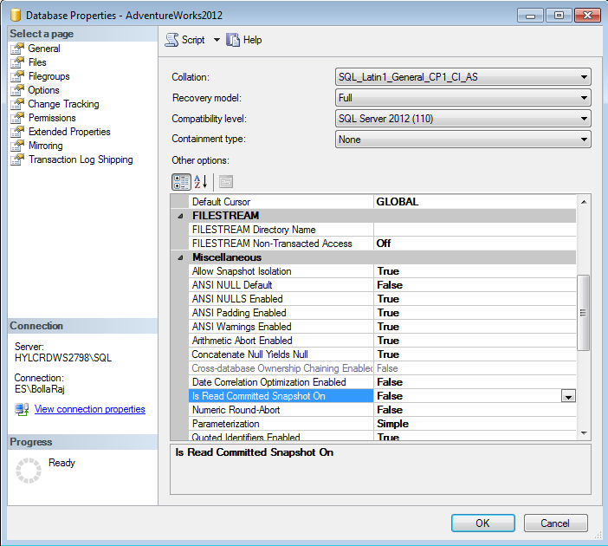

2.Make **Read committed Snapshot** is True

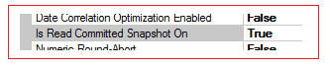

You can also do through query

USE [master]

GO

ALTER DATABASE [AdventureWorks2012] SET READ_COMMITTED_SNAPSHOT ON WITH NO_WAIT

GO

Note:

*If READ_COMMITTED_SNAPSHOT is set to ON, the Database Engine uses row versioning to present each statement with a transitionally consistent snapshot of the data as it existed at the start of the statement. Locks are not used to protect the data from updates by other transactions.*

<https://msdn.microsoft.com/en-us/library/tcbchxcb(v=vs.110).aspx>